Traditions and Story quilts
Grade: 3
Time: 30-60 minutes
Materials: Paper, pencil and coloring materials
Standards: Students will relate artistic skills, ideas and work with personal meaning and external context (Standards 3.V.CO.1–2)
Social studies: Students will learn about traditions of well know artist and make connections to their own personal narrative.

Meet Faith Ringgold 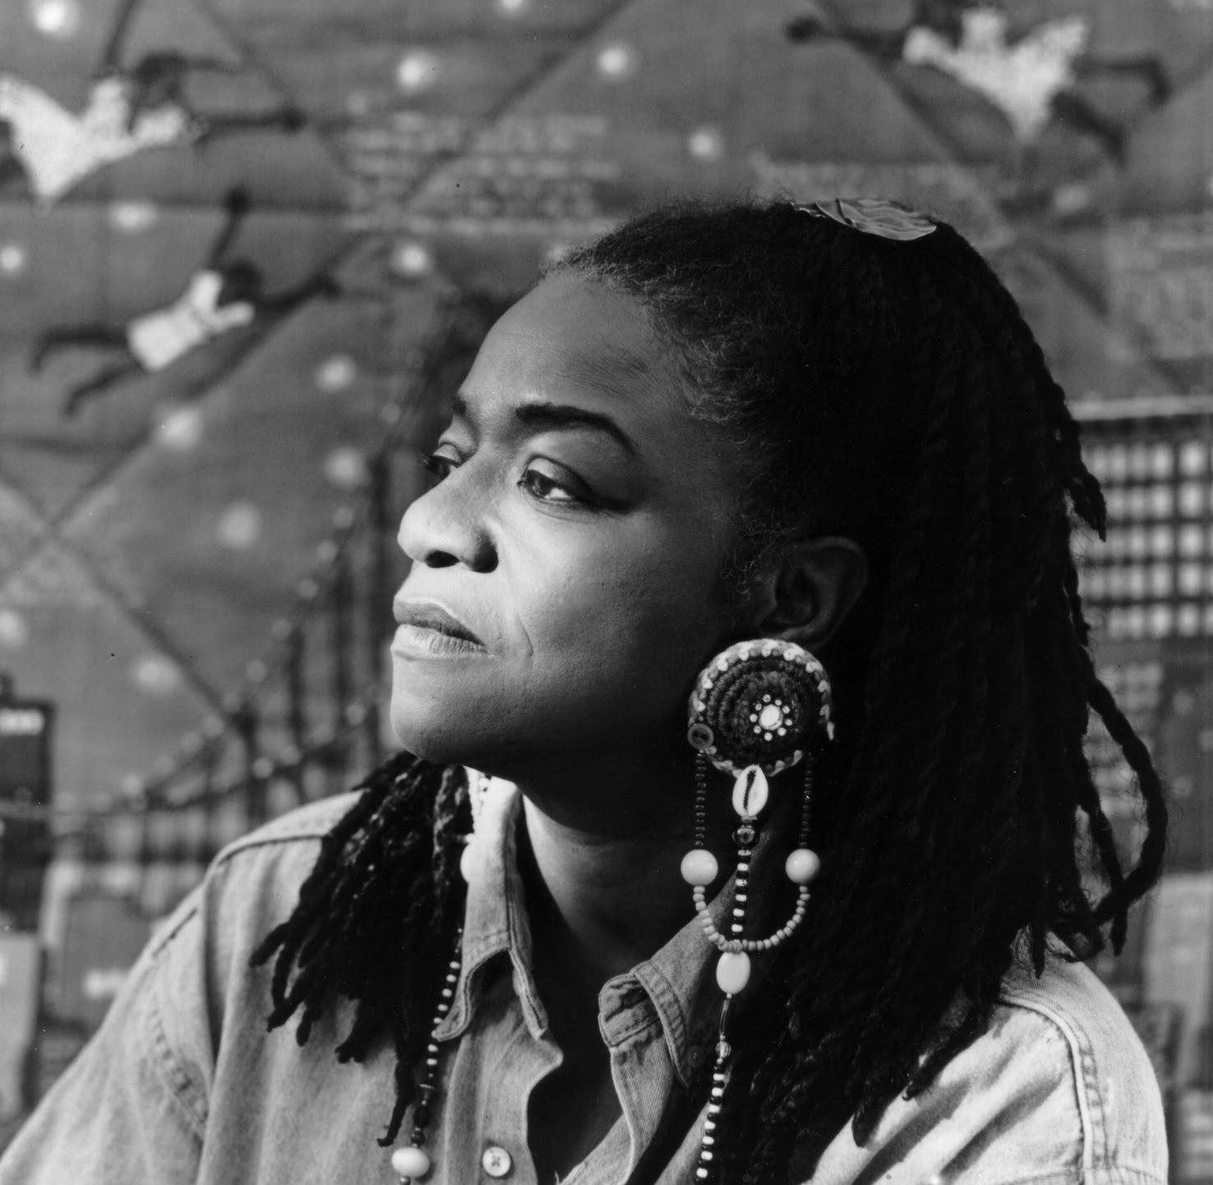 Faith was born in Harlem, NY in 1930. She was influenced by her family’s African traditions, and her own stories. She began making story quilts that told stories about an event from her memory or memorable people. She would paint the image in the middle on canvas and then quilt patterns and colors around the outside. Not only was she an artist, she was also a major advocate (Someone who fights for something they believe in.) for women’s rights to show in museums and an author writing and illustrating several books. 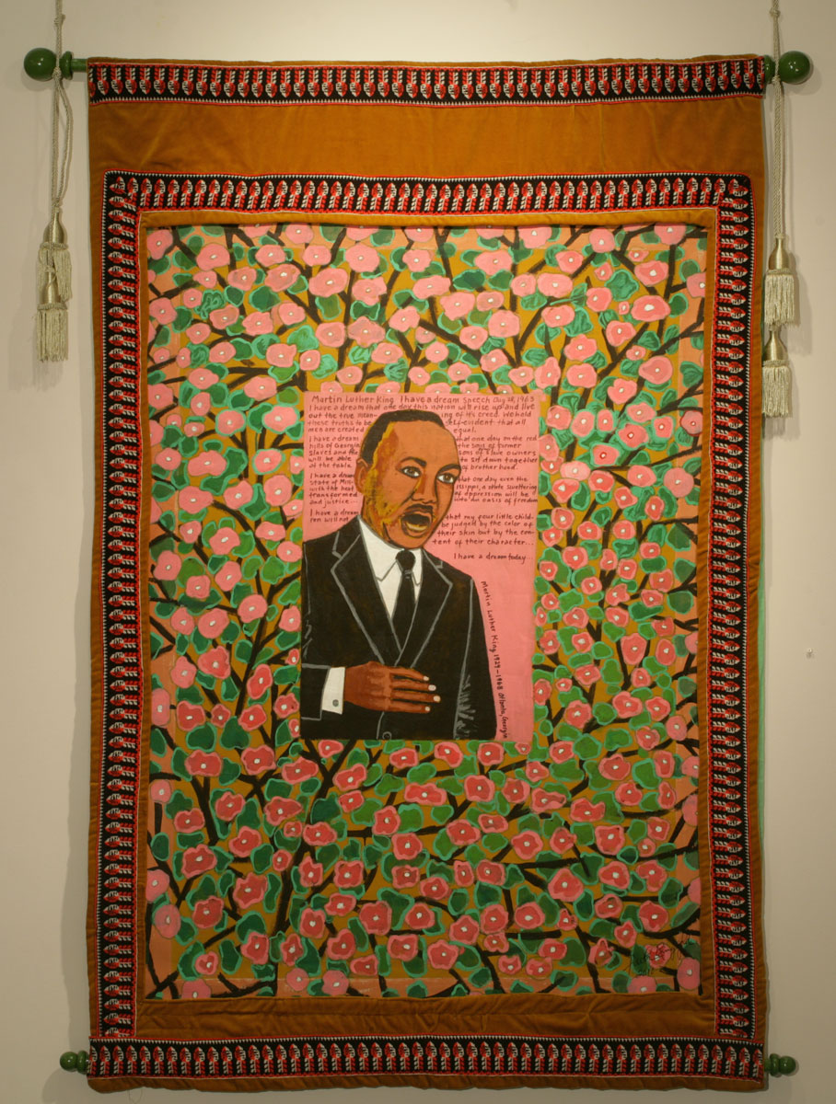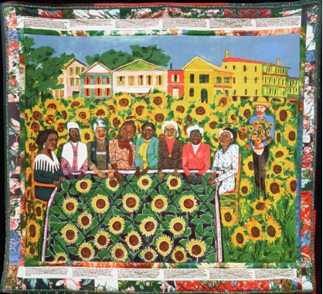
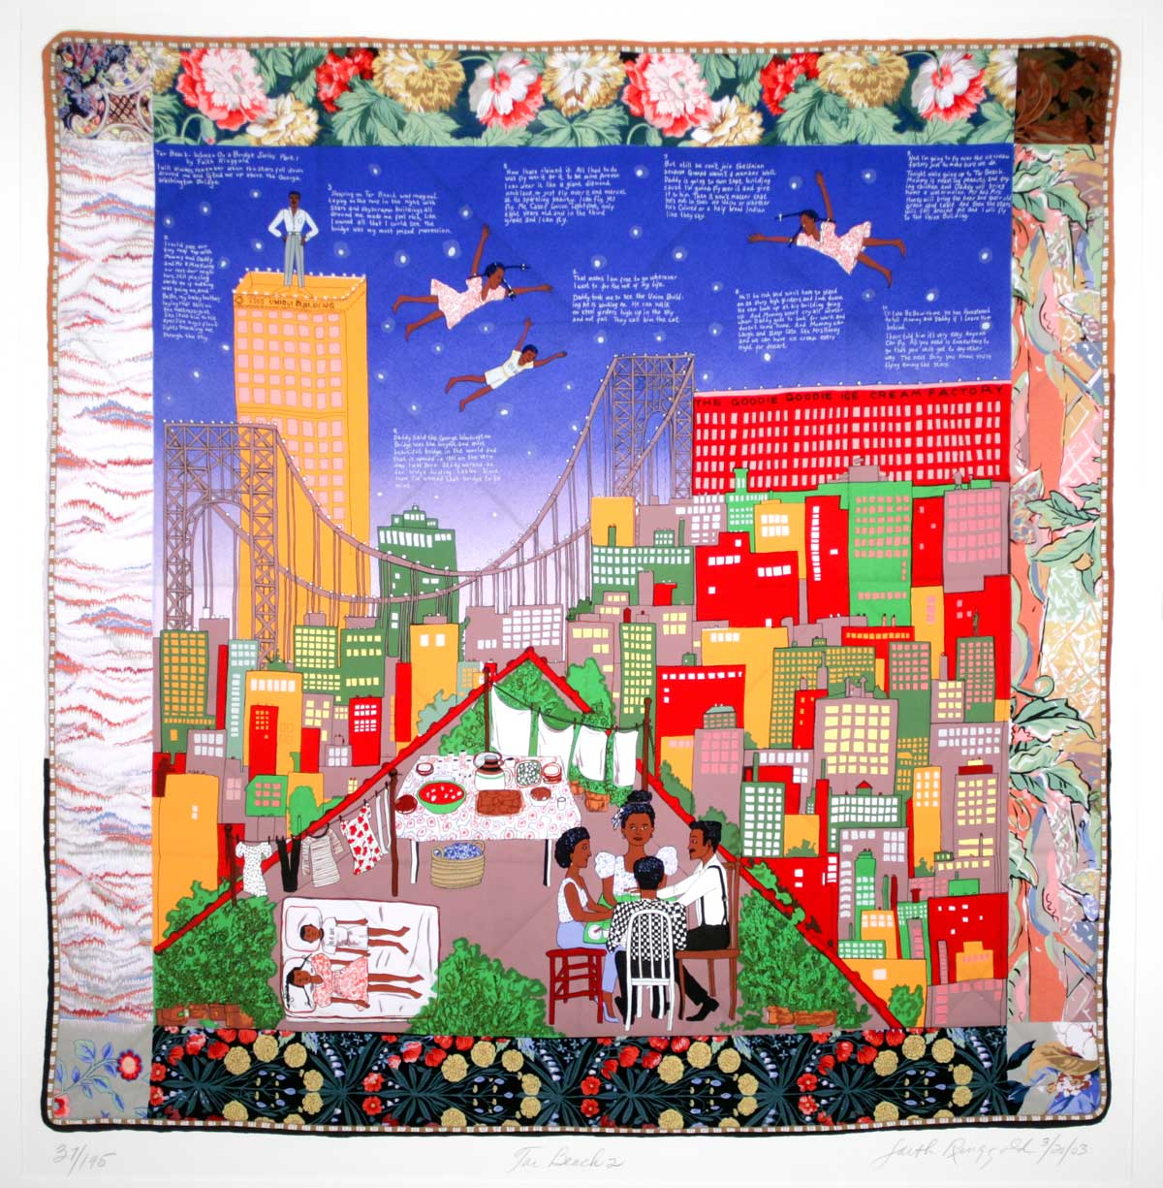 Tar beach is a story about growing up in Harlem and the fond memories she had about it being so hot in the summer that they would take their mattress to the top of the building and families would meet and eat and sleep together on the roofs.

Your assignment:
- Fill out the following question and include as much detail as you can in your writing. Write 1 paragraph or 5 sentences that describe your favorite family tradition and why? It can be a simple thing that your family does, or something that you look forward too each year. Think Holidays, vacations, family time and share it as though you were telling me in person.
- Using the attached piece of paper or your own, draw me an image of what that tradition might look like. Don’t forget to draw big, no little people Give me as much detail in the background so that if I didn’t know the story, I could guess it just by looking at it. I can’t wait to see what you do!

What is your favorite family tradition and why? ________________________________________________________________________________________________________________________________________________________________________________________________________________________________________________________________________________________________________________________________________________________________________________________________________________________________________________________________________________________________________________________________________________

